the Julia Set, and the Mandelbrot Set

MuPad Simulation

1. All six axioms and their corresponding rules can be described in the following rendered images:

Axiom and Rule 1 Axiom and Rule 2

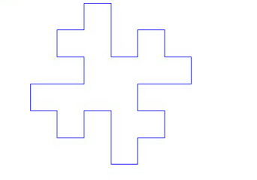

Axiom and Rule 3 Axiom and Rule 4

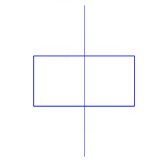

Axiom and Rule 5 Axiom and Rule 6

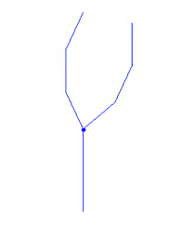

2) Next, multiple generations were run on these basic fractal patterns to produce a wide variety of aesthetic and commonly seen patterns

Scheme 1 With 3 Generations Scheme 2 With 3 Generations

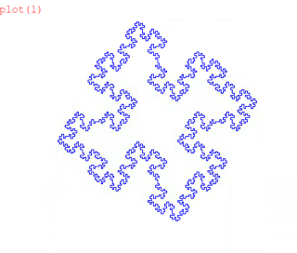

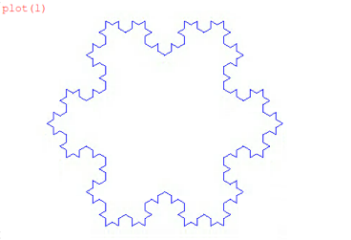

Scheme 3 With 3 Generations Scheme 3 With 5 Generations

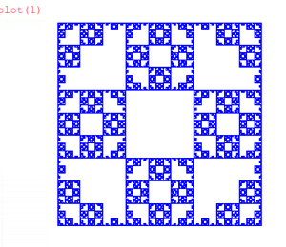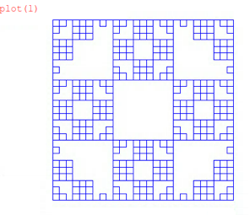

Scheme 4 With 3 Generations Scheme 4 With 5 Generations

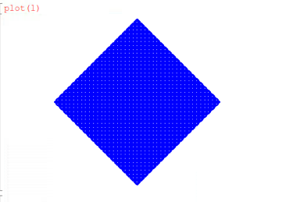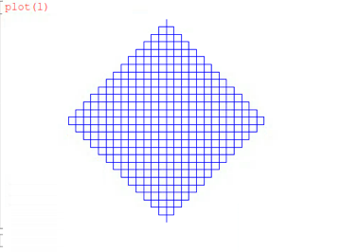

Scheme 5 With 3 Generations Scheme 5 With 5 Generations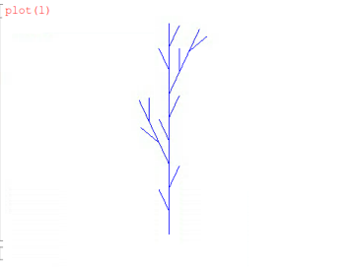

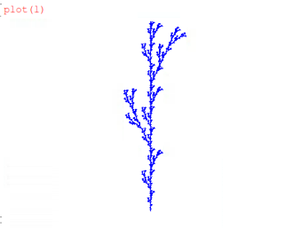

Scheme 6 With 3 Generations Scheme 6 With 5 Generations

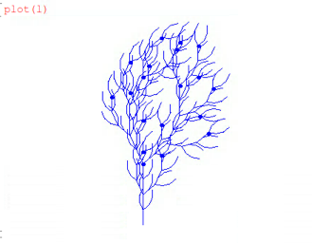

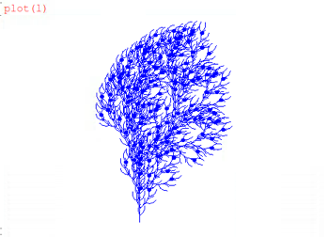

3) The final two patterns, specifically schemes five and six stand out from the rest of the others.This is because they represent biological growth patterns. They do not have harsh 90 degree rotations in their original axioms and rules because these 90 degree angles maximize load on objects which can hinder plant growth. They also both have a single stem and branches that reach upwards in their first generation of the rule and axiom this characterizes plants growing up towards the sunlight. One can also conclude that plants repeat this basic pattern growth until they have grown a sufficient size; this shows the predictable and repeated pattern of biological growth.

Mandelbrot cool close-ups (jacob):

The Mandelbrot Set

Here are two close zooms of aesthetically appealing zooms on the Mandelbrot Set. The code is attached to the final page of the project report.

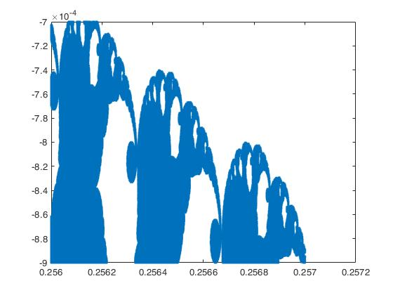

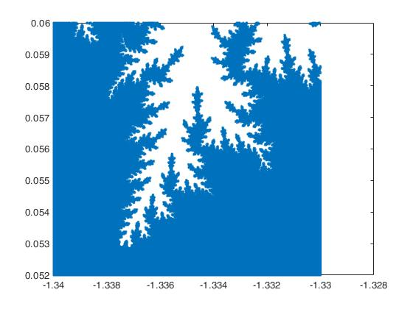

The Julia Set

The code for the Julia Set is attached and can be referenced in the back. However, here are the aesthetic images gained from particular c values of the Julia Set.

C = -0.8\*0.15\*j C = 0.295+0.55\*j

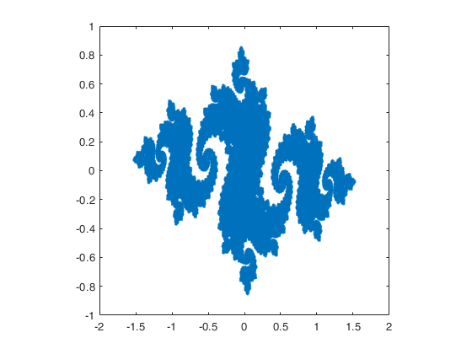

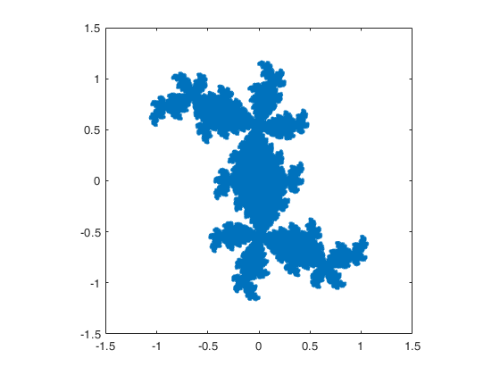

BioMorphs and The Julia Set

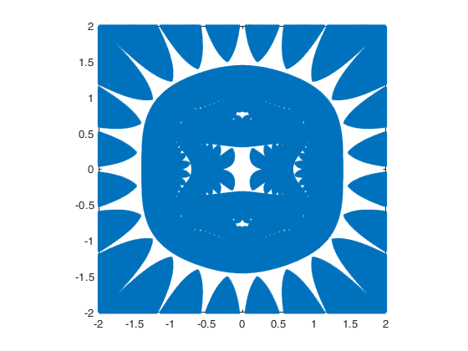

Here is an example of a biomorph obtained by the extra divergence criterion. It was obtained with a c value equal to 0.8.

This Biomorph is obtained through a c = 0.47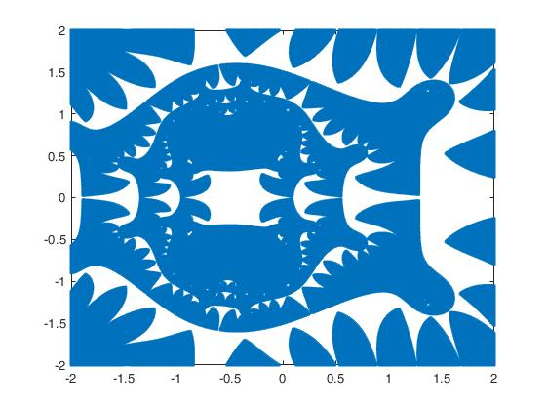

Then here is another final biomorph with c value = 0.91

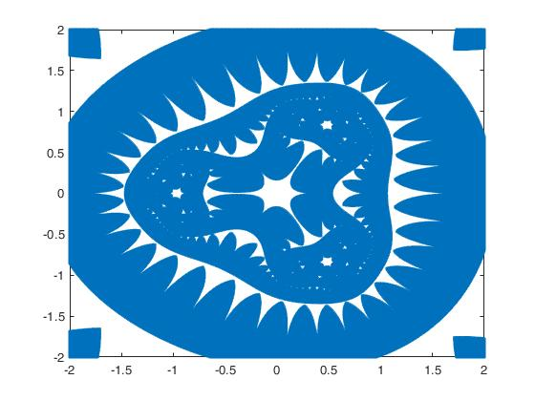

Here are the biomorphs that are associated without the extra divergence criterion. They look significantly less appealing.

C = 0.8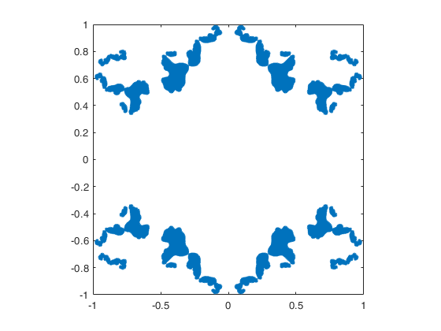

C = 0.457

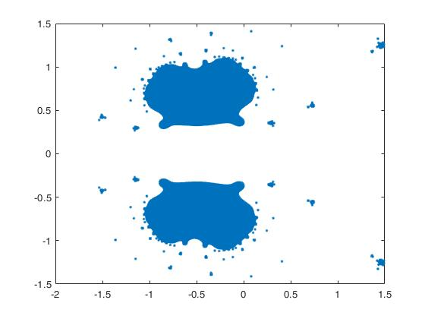

C = 0.91